**PFCS Mac TS Setup Instructions**

1.  Open the Apple App Store

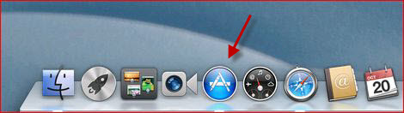

2.  Search for “Microsoft Remote Desktop” (MRD) and initiate the download/installation of MRD; have the user input their Apple ID credentials if requested

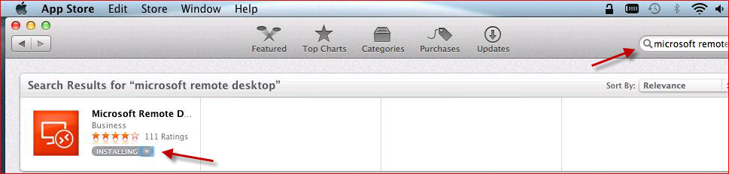

3.  Once the application has been installed click on a blank area of the desktop to invoke the Finder menu.  On the Finder menu click Go and then Applications to find MRD

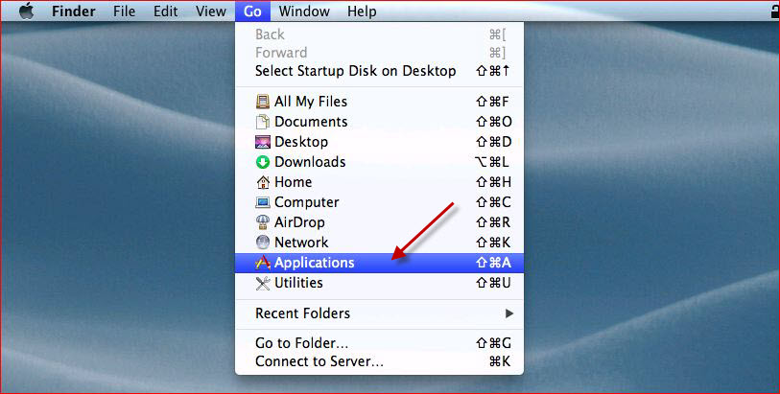

4.  Drag the MRD icon to the dock if the user would like it there

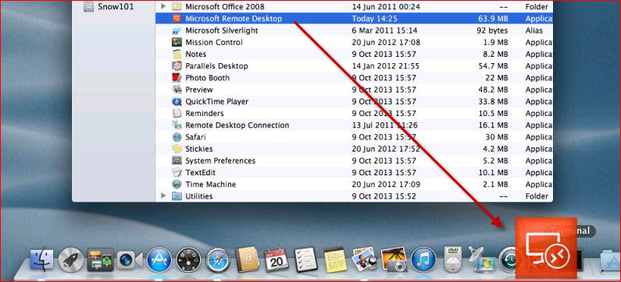

5. Launch MRD and click on the New button.  Configure RDP settings normally by entering the domain\username into the Username field. Then click the Gateway drop-down to add a gateway in the next step

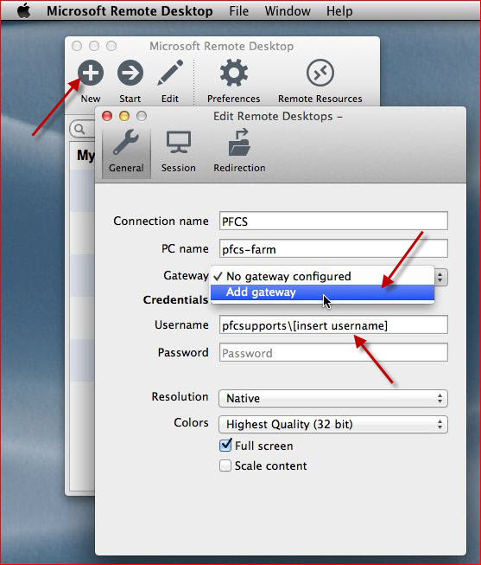

6. Click the plus sign to add a new gateway and use the red “x” button at the top-left of each window to apply changes made and to exit the configuration

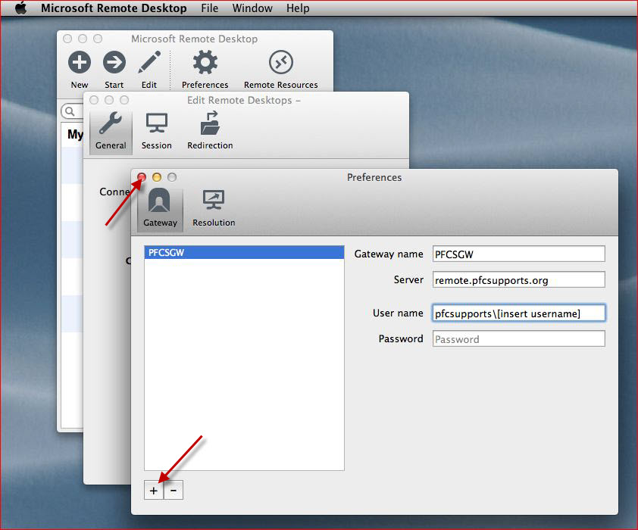

7. Connect to the terminal server cluster by highlighting the connection that was created and using the Start button

